

**Netflix Shows Rating Data Analysis**

Submitted to the

**Department of Master of Computer Applications**

in partial fulfillment of the requirements of

# Hadoop Ecosystems (MCAE03)

by

Name: Pratim Dutta

**USN: 1MS18MCA24**

**RAMAIAH INSTITUTE OF TECHNOLOGY**

(Autonomous Institute, Affiliated to VTU)

Accredited by National Board of Accreditation & NAAC with ‘A’ Grade MSR Nagar, MSRIT Post, Bangalore-560054

[www.msrit.edu](http://www.msrit.edu/) **2019-2020**

**CERTIFICATE**

This is to certify that the Mini Project entitled “**Netflix Shows Rating Data Analysis**” is carried out by **Pratim Dutta - 1MS18MCA24,** a bonafide student of Dept. of Master of Computer Applications, Ramaiah Institute of Technology, Bangalore, in partial fulfillment for the **Hadoop Ecosystems (MCAE03)** during the year 2019- 2020. It is certified that all corrections/suggestions indicated for Internal Assessment have been incorporated in the mini-project report deposited in the department.

# Faculty Signature

**Ms. B N Nithya (B2)**

# ABSTRACT:

The project **“Netflix Shows Rating Data Analysis”** contains the field such as particular Title along with their Rating Level, Rating Description, Release Year, User Rating Score, User Rating Size,

The purpose of this project is to analyze and identify the Rating of Movies/Shows, their Rating Level type, Rating Description(Category type), Old and New Releases along with High and Low User Rating Score.

Tools used:

* Flume
* Hadoop
* Pig

Flume is used to load an original data file (**netflix.csv** file) from local memory to HDFS, Hadoop is used to store the data from flume, by creating a directory in it.

Pig is used to process the commands, the data loaded in HDFS are processed here to produce a desired output.

**Original Data File:**

This is the sample data of **netflix.csv** file**,** taken to analyze.

The fields contain **title, rating, ratinglevel, ratingdescription, release_year, user_rating_score, user_rating_size**

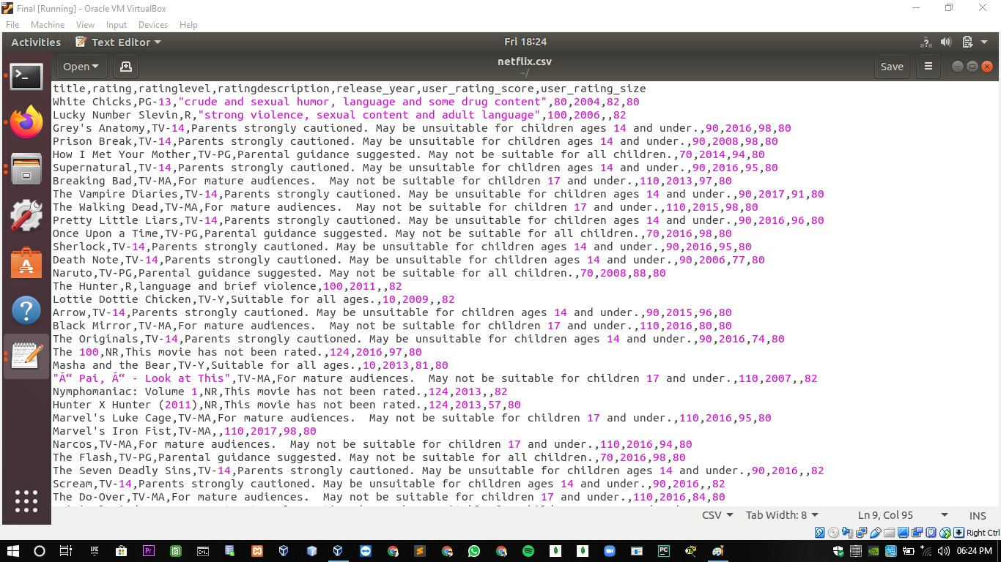

**Command to check services in Hadoop:**

Initially we have to start the Hadoop using **start-all.sh.**

And then use **jps** command to check if all services are running properly in Hadoop.

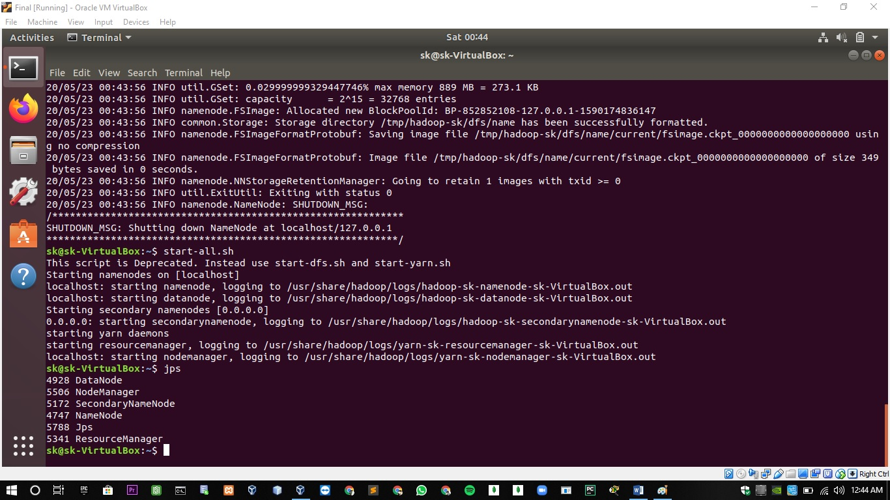

**Creating a directory:**

Creating a directory in Hadoop named flume_pratim, the purpose of creating this directory is to store the flume data in hdfs.

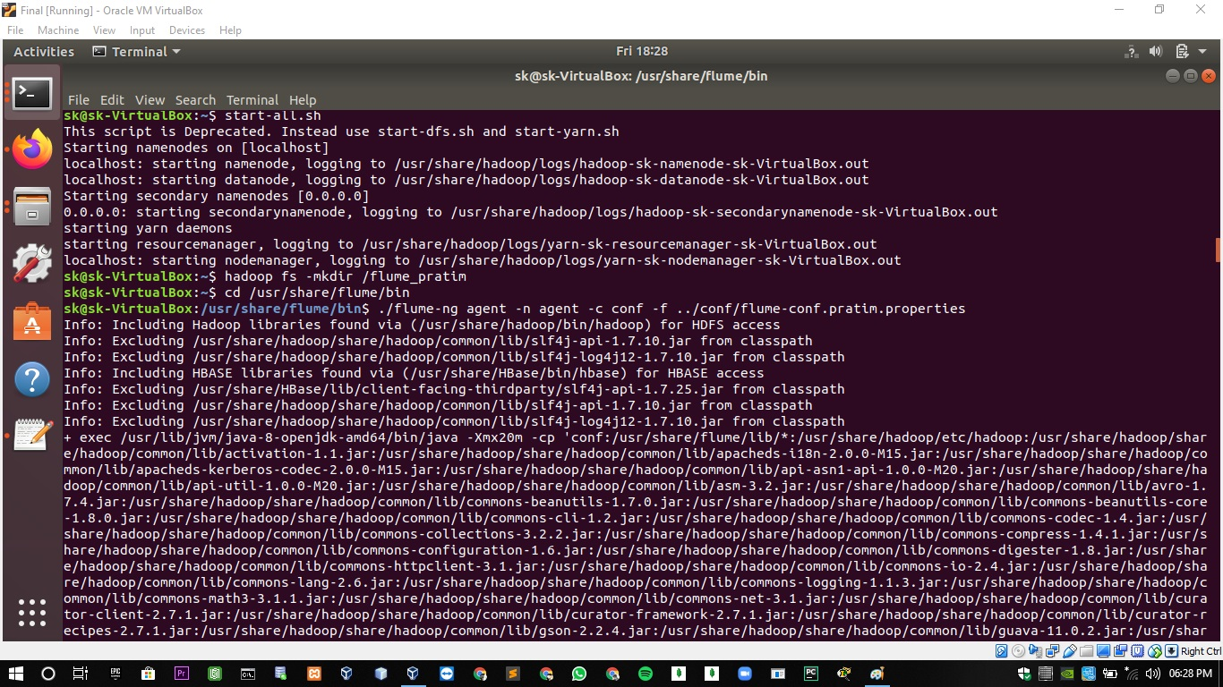

**Flume Configuration:**

Configuration has to setup such as type, bind, port number, type of file, write format, and rollInterval.

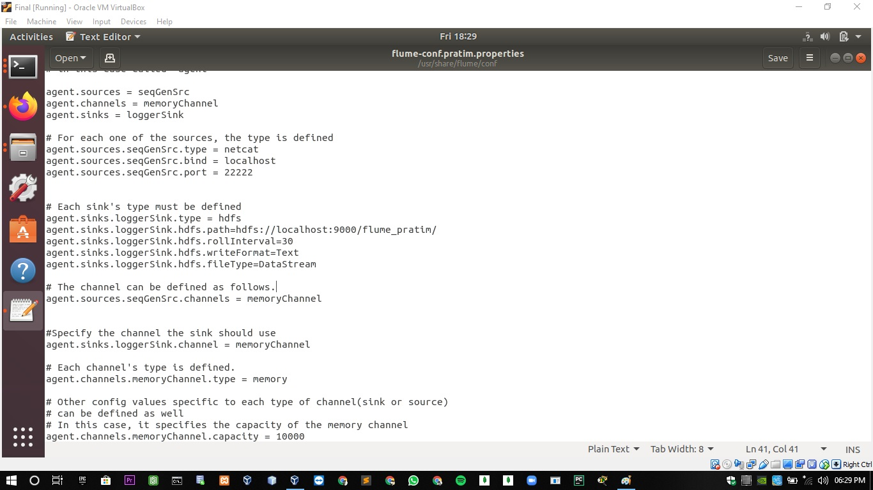

**Transferring data into flume:**

Transferring the data file from local memory to hdfs via flume using a command:

./flume- ng agent –n agent –c conf –f ../conf/flume-conf.pratim.properties

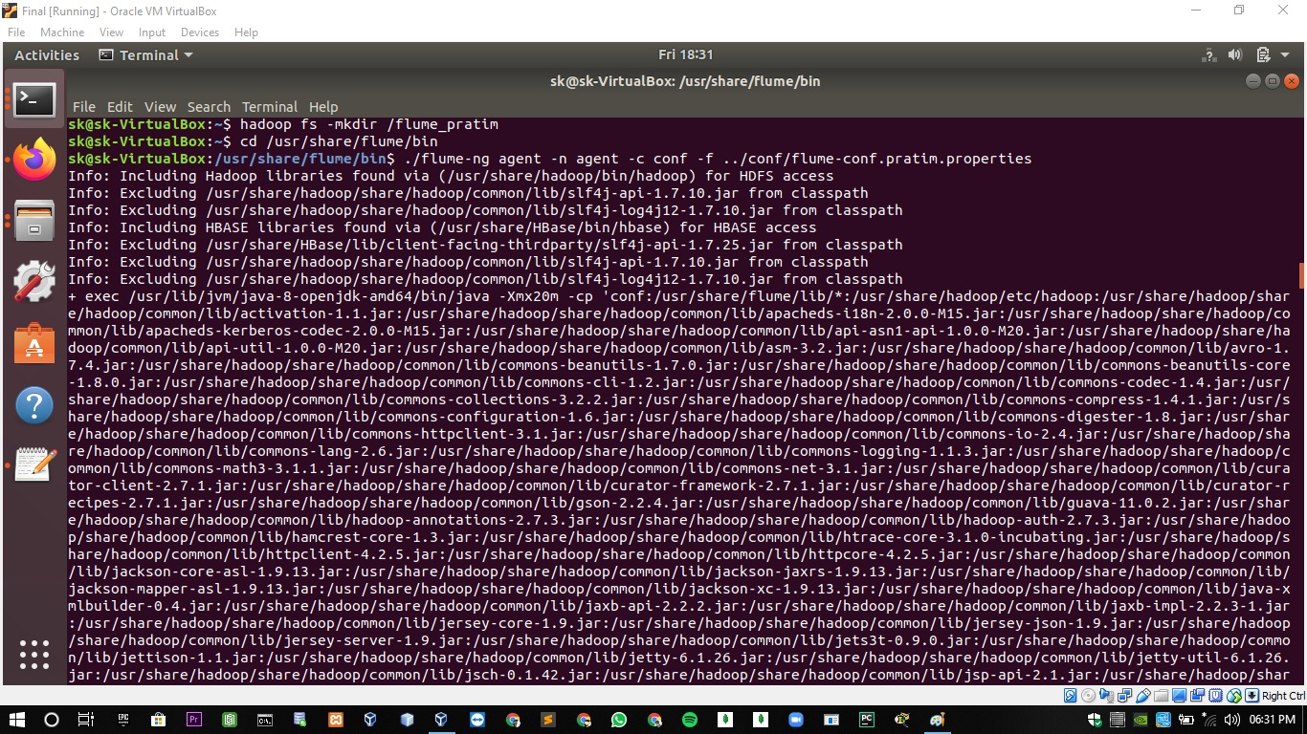

**Loading data into hdfs:**

Successfully transferring of data into hdfs.

$ head –n 1000 netflix.csv | nc localhost 55555

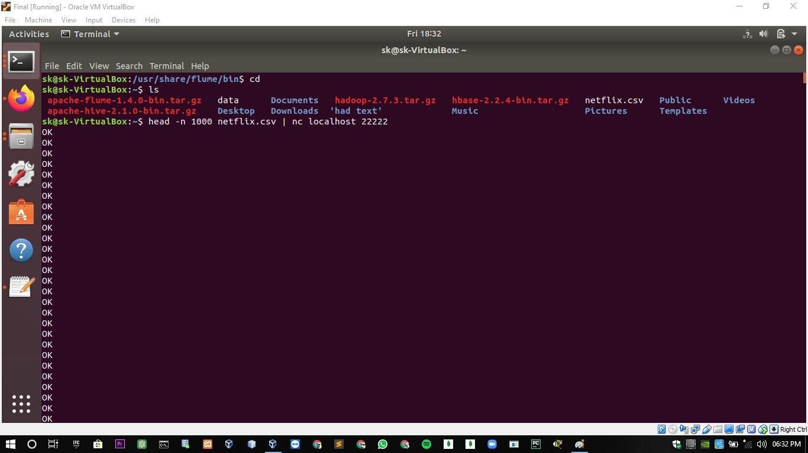

# Browser view of Flume data files:

View of flume files loaded in hdfs in browser.

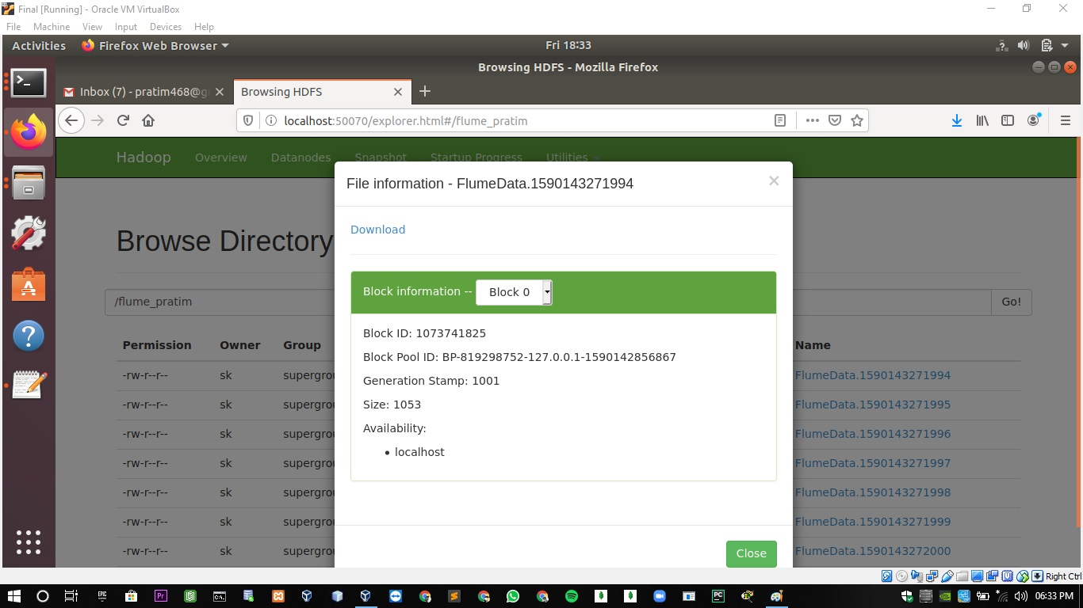

**Sample view of Flume data file:**

Downloaded flume files from browser where data is transferred in the form of chunks.

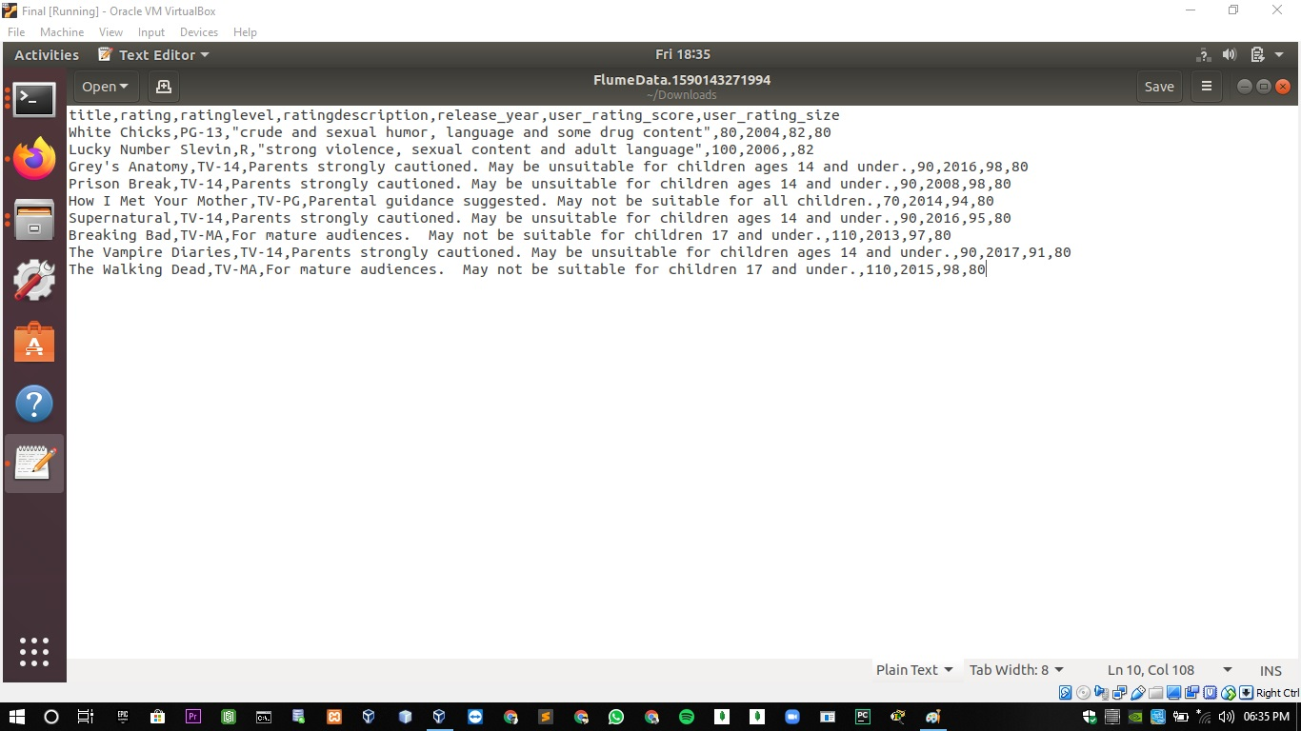

**Starting the pig:**

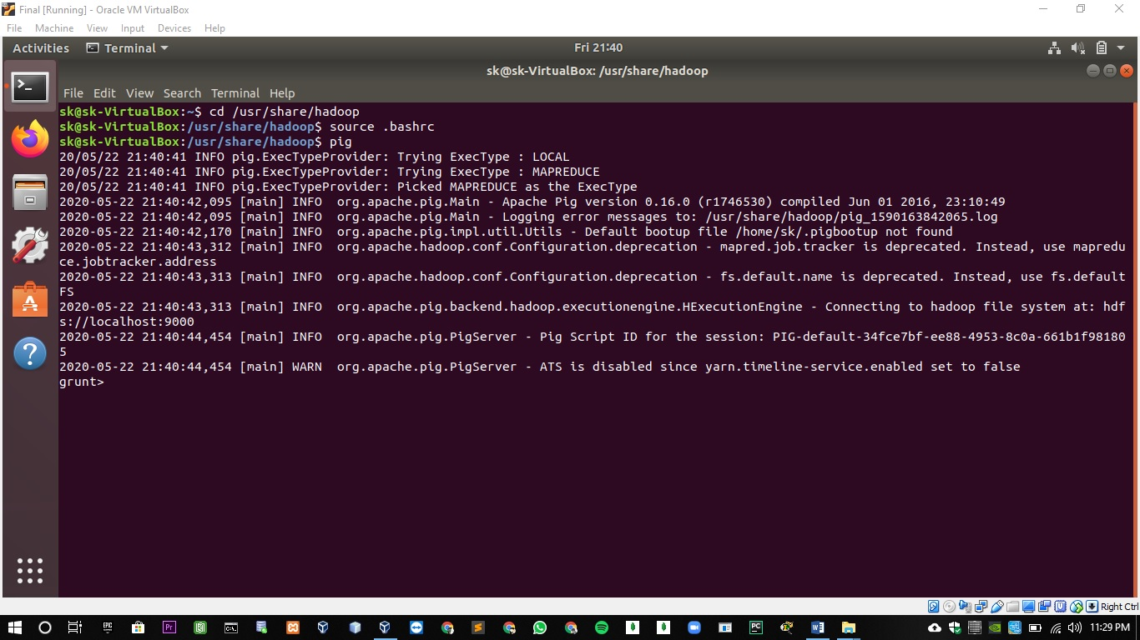

**PIG Commands:**

**Loading the Flume data into the Pig Storage according to its appropriate datatype.**

grunt> A = LOAD '/flume_pratim' USING PigStorage(',') AS (title:chararray,rating:chararray,ratinglevel:chararray,ratingdescription:int,release_year:int,user_rating_score:int,user_rating_size:int);

grunt> dump A;



**Output:**

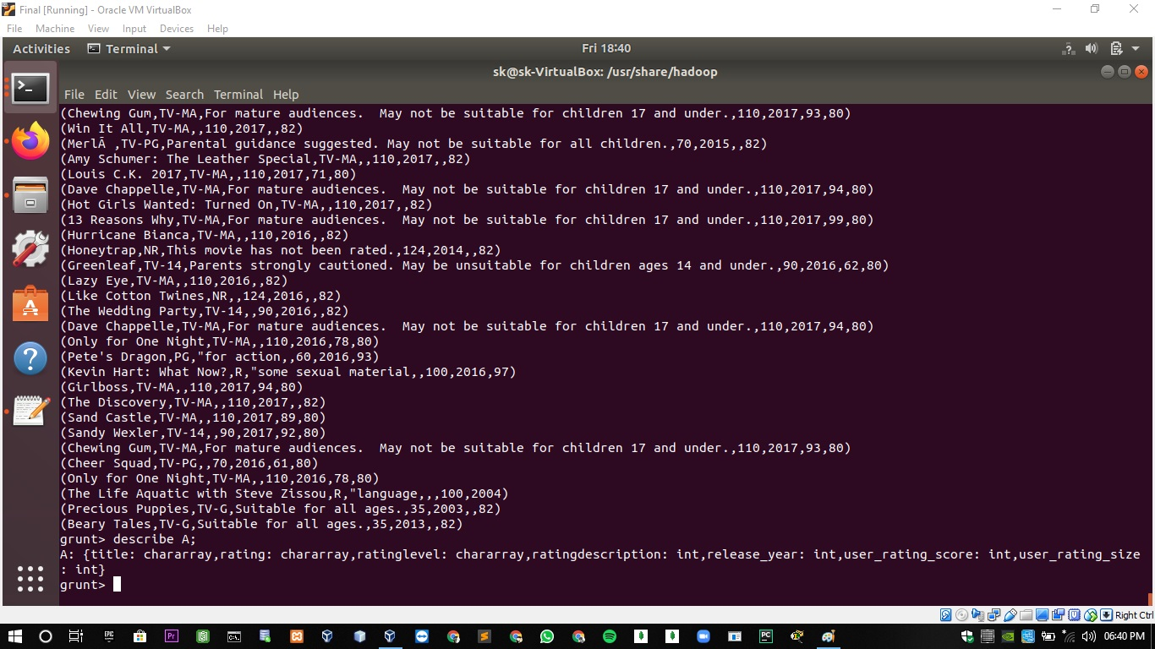

**1. Pig Command to list records of movies/shows in Ascending Order of their Title.**

grunt> q1 = order A by title;

grunt> dump q1;

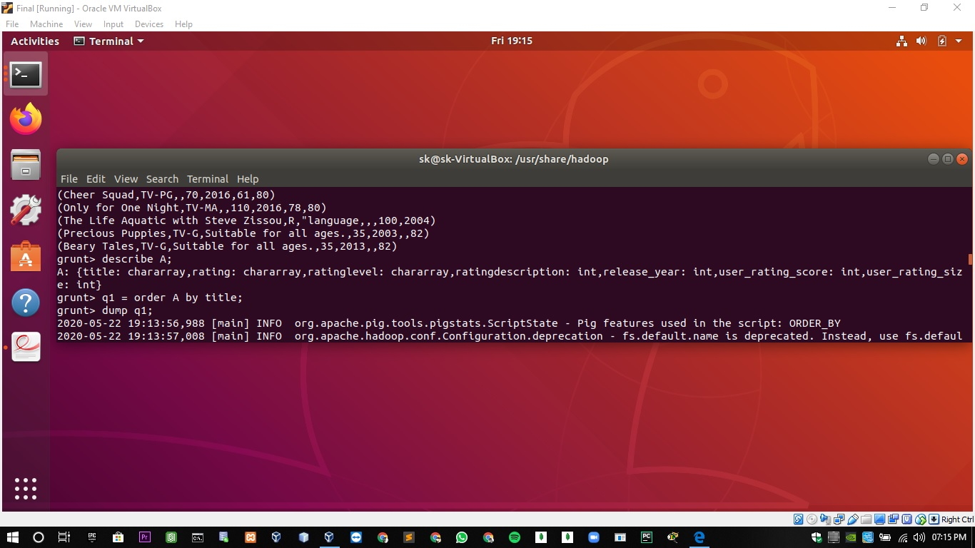

**Output:**

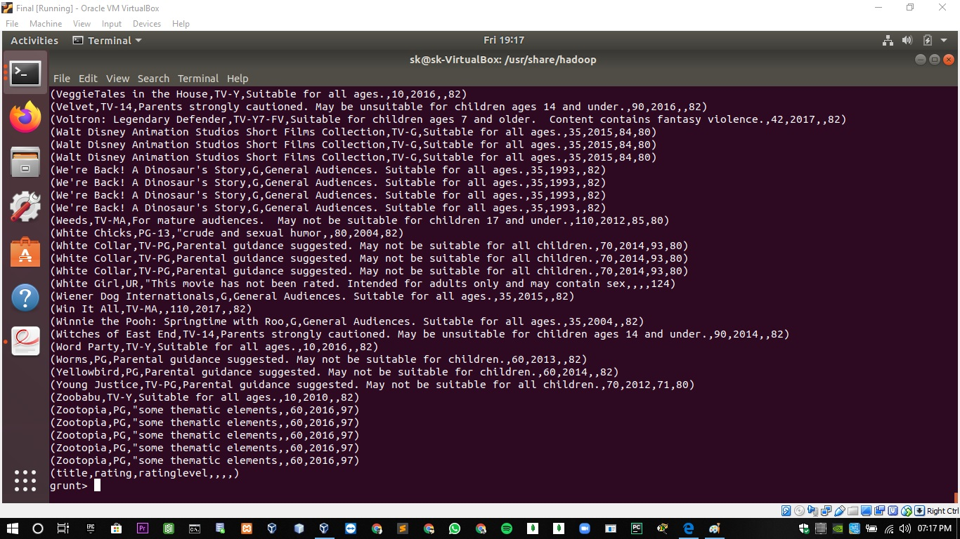

**2. Pig Command to filter the records which includes Rating as "TV-14" and "TV-Y".**

grunt> q2 = filter A by (rating=='TV-14') or (rating=='TV-Y');

grunt> dump q2;

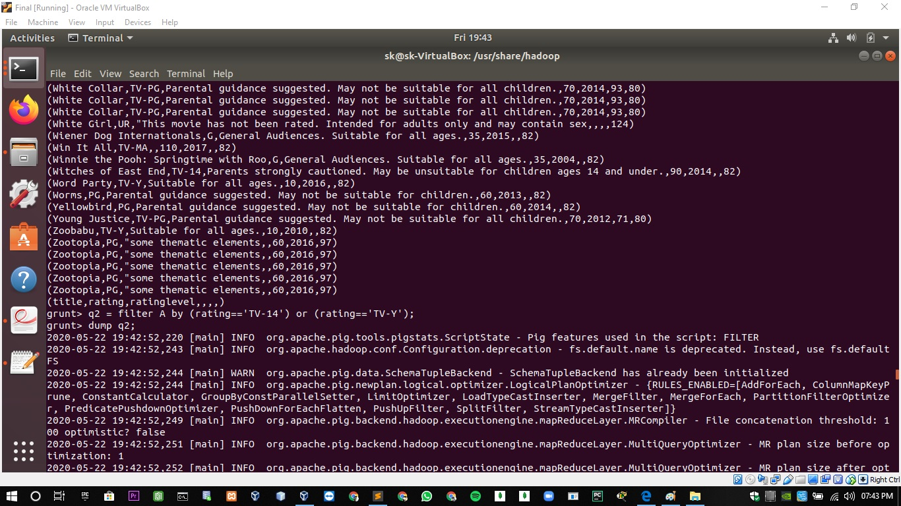

**Output:**

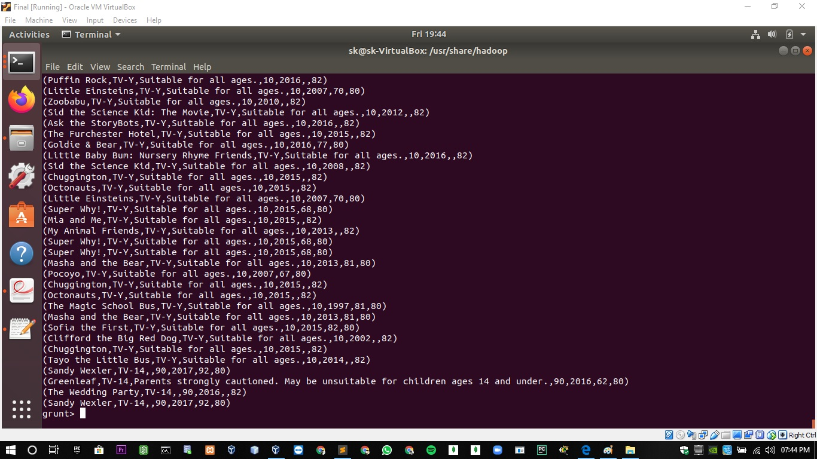

**3. Pig Command to filter the records which consists if Rating Level as "Suitable for all ages."**

grunt> q3 = filter A by (ratinglevel=='Suitable for all ages.');

grunt> dump q3;

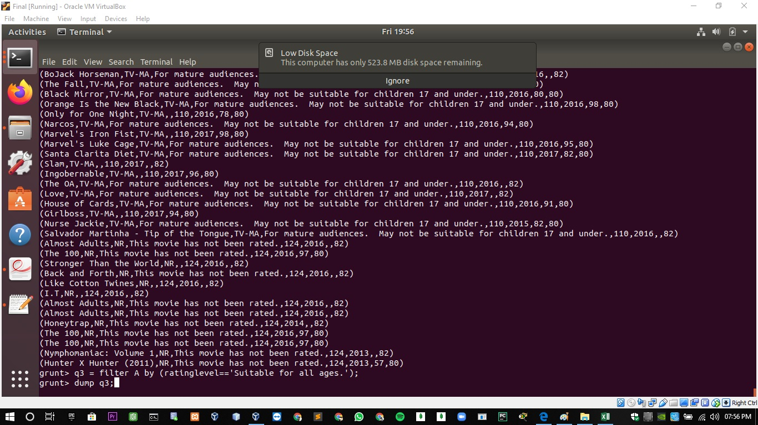

**Output:**

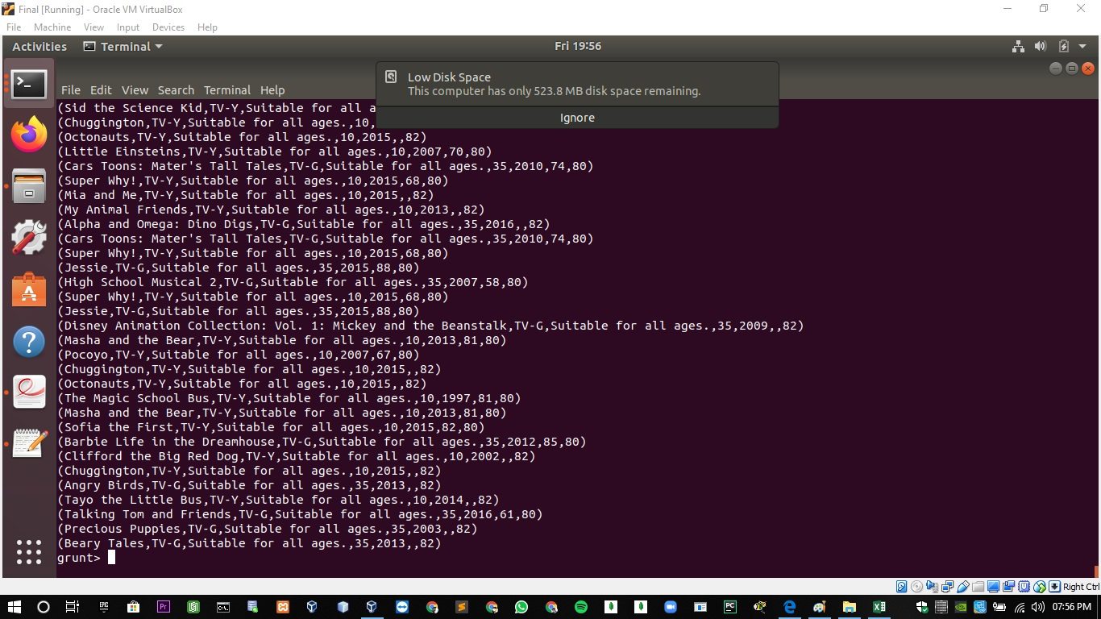

**4. Pig Command list records of movies/shows according to oldest to newest of their Release Year.**

grunt> q4 = order A by release_year;

grunt> dump q4;

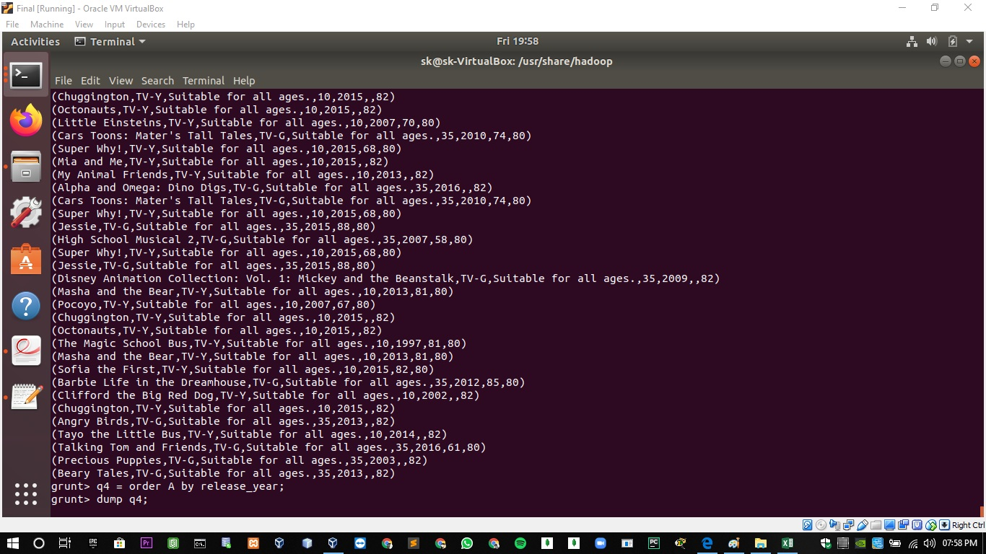

**Output:**

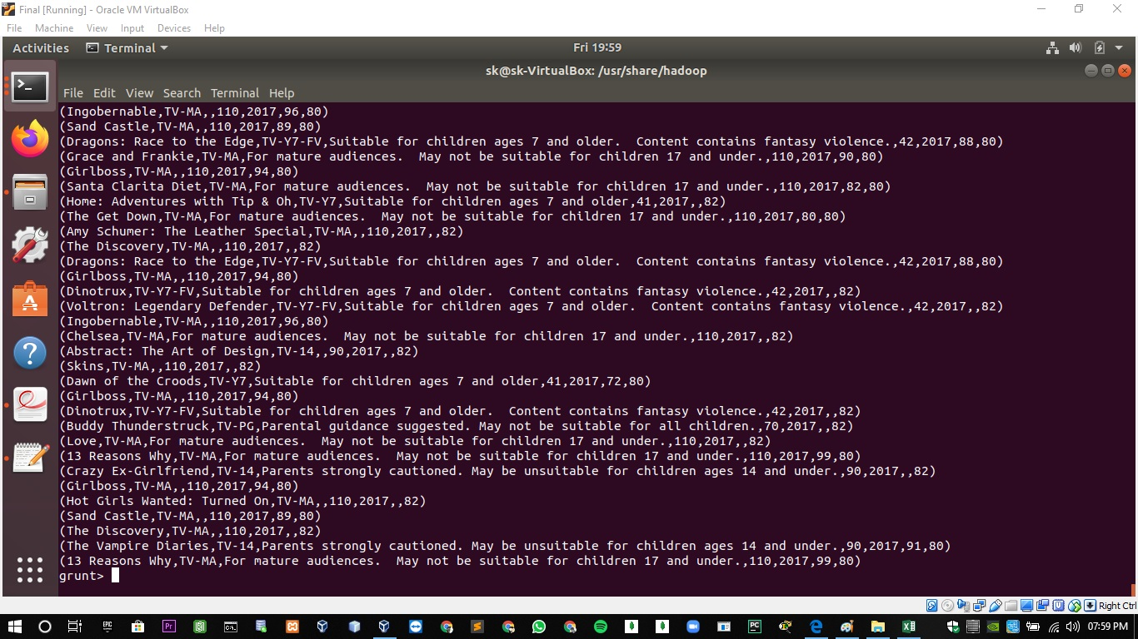

**5. Pig Command to list records of movies/shows according to newest to oldest of their Release Year.**

grunt> q5 = order A by release_year desc;

grunt> dump q5;

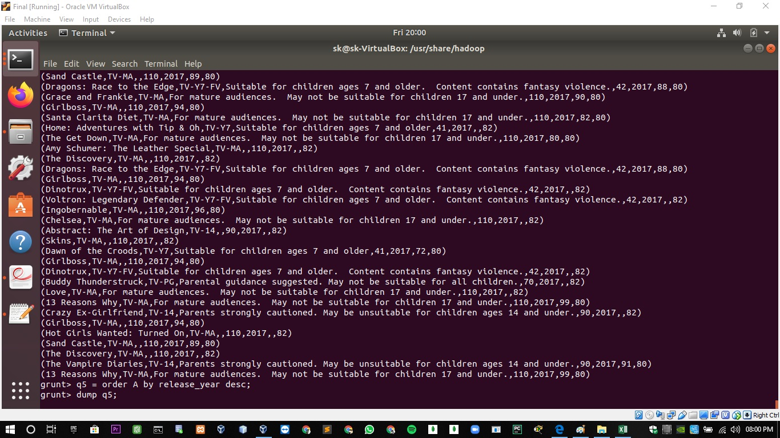

**Output:**

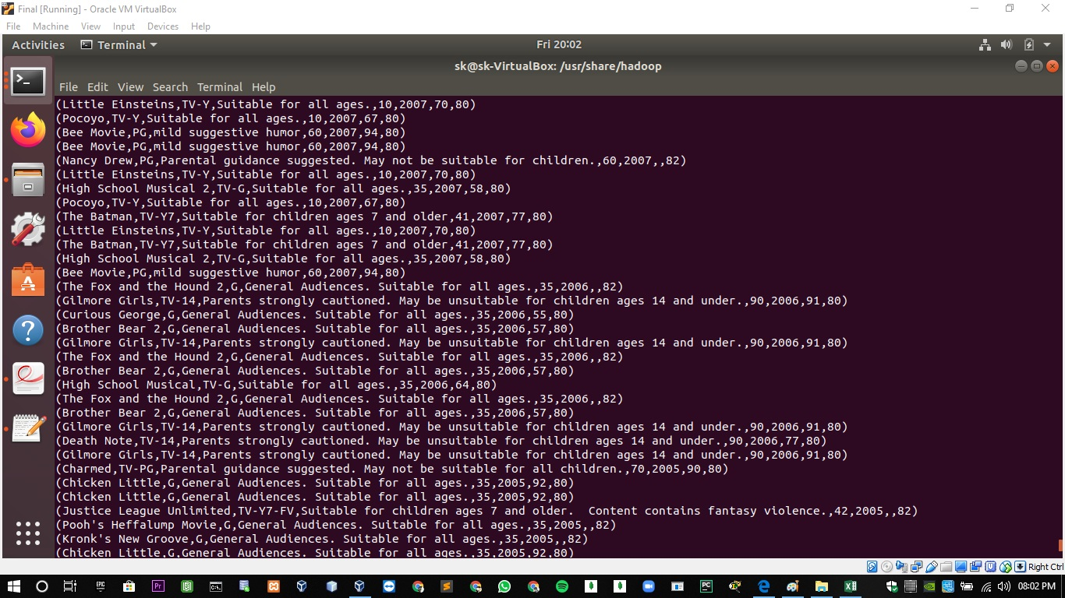

**6. Pig Command to list records of movies/shows according to lowest to highest of their User Rating Score**

grunt> q6 = order A by user_rating_score;

grunt> dump q6;

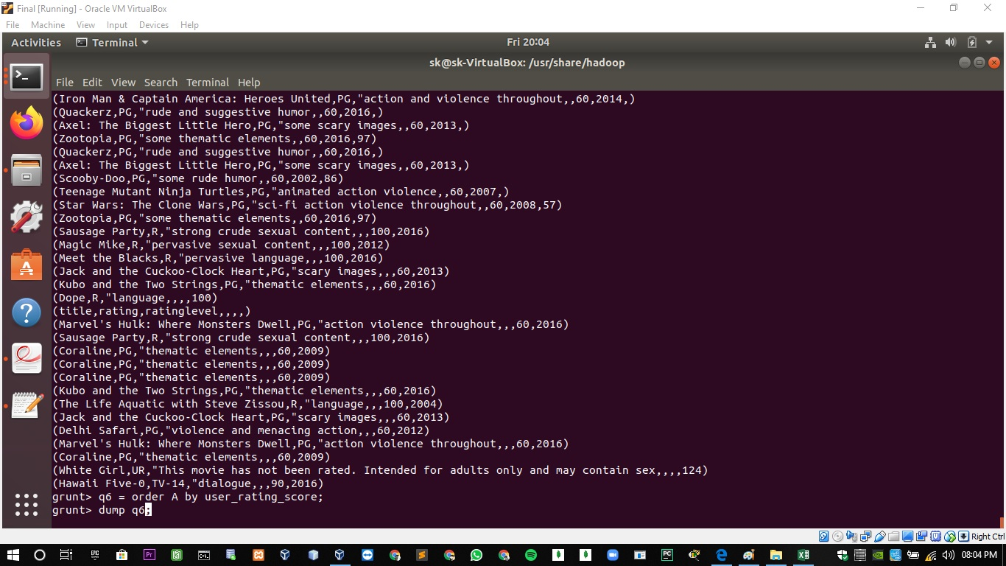

**Output:**

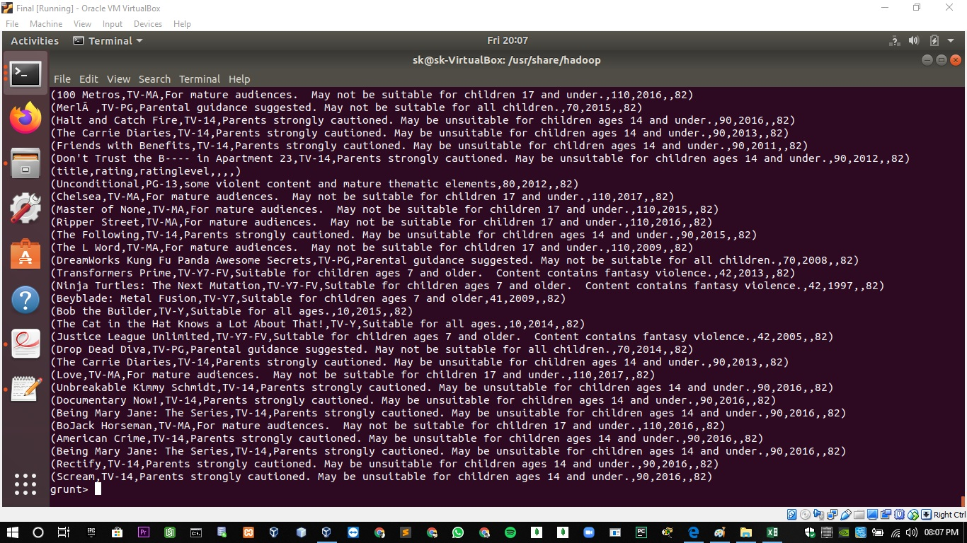

**7. Pig Command to list records of movies/shows according to highest to lowest of their User Rating Score**

grunt> q7 = order A by user_rating_score desc;

grunt> dump q7;

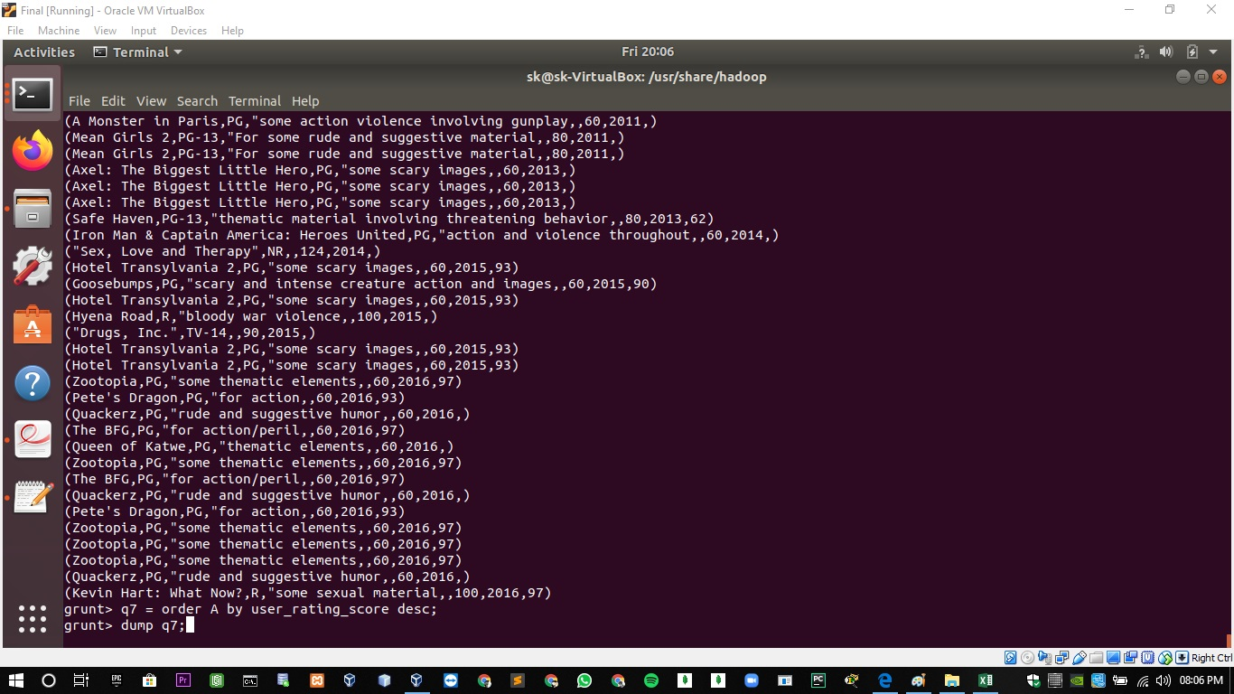

**Output:**



**8. Pig Command to filter the records of movies/shows which was released on the year "2017."**

grunt> q8 = filter A by (release_year==2017);

grunt> dump q8;

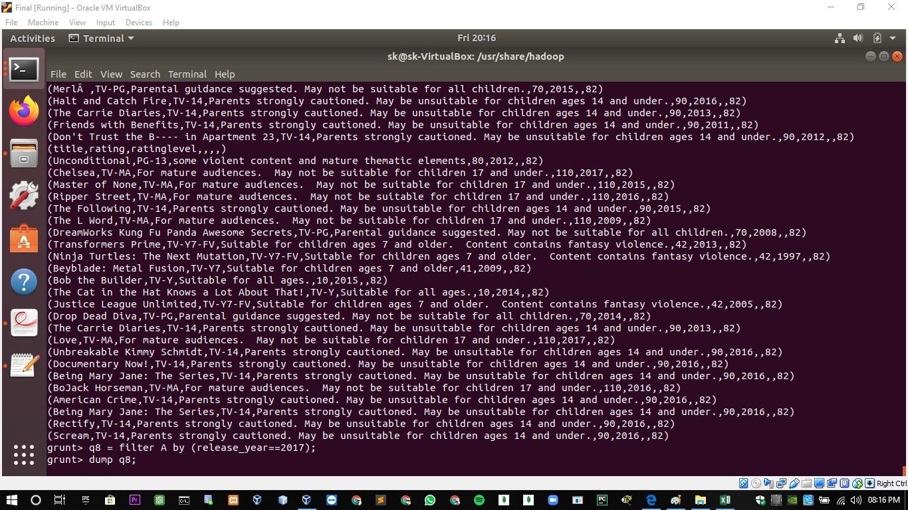

**Output:**

